I’ve had something of a love-hate relationship with the *Watchmen* comic series since it first premiered in September 1986.

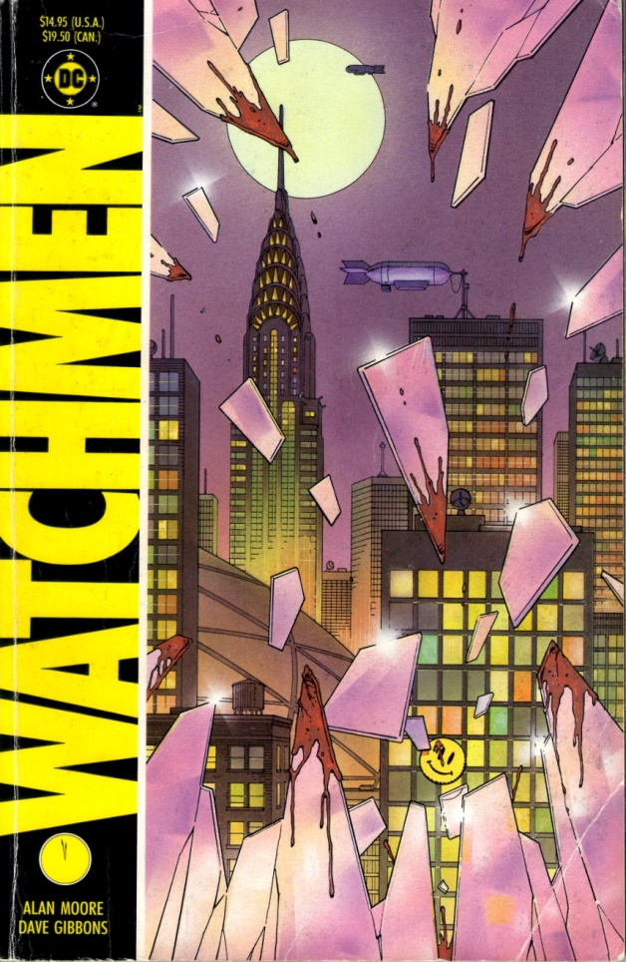

This admission may seem something of a surprise given that the [Wikipedia article on the *Watchmen*](https://en.wikipedia.org/wiki/Watchmen) notes that “several critics and reviewers [consider it] to be one of the most significant works of 20th-century literature”, that “*Watchmen* was recognized in Time's List of the 100 Best Novels as one of the best English language novels published since 1923”, and that “[t]he BBC described it as ‘The moment comic books grew up.’”.

I’ve heard things like this since *Watchmen* hit the stands and I scraped enough money to buy it in its original serialized form. But I have never been able to fully embrace it nor to clearly explain why. That’s 30 years of pondering what is it about this particular comic series that attracts me and what pushes me away. It’s 30 years of wrestling with how to clearly articulate the reasons why. Finally, I think that after all that time I can, at least, put down the basic structure behind my ambivalence towards *Watchmen*.

In a nutshell, I think the physical composition and narrative structure is one of the best I’ve ever seen while the underlying message and philosophy is empty and nihilistic and vapid.

I’m going to spend this column and the next expanding on particular points that support this assertion starting with the part of *Watchmen* that I like – its physical composition and the narrative structure. In the next column, I’ll discuss the underlying themes and messages that produce a philosophy that is both nihilistic and intellectually vapid.

But before launching into the review, a quick synopsis of the plot is in order. For those unfamiliar, *Watchmen* is set in an alternative timeline where ‘normal people’, inspired by the pulp novels of the 1930s and 1940s, have become masked adventurers for a whole host of reasons, which, according the psychoanalysis featured in the story, include a desire to address societal woes and do good, the need to get their kicks (physically or sexually), or because they are seeking their fame and fortune. Being a bit of a fad, these normal folk in extraordinary costumes see their popularity rises and fall just as any fad does. Things change about a decade later when the physicist Jon Osterman, through fate or blind randomness, becomes the superman of his world. Dubbed Doctor Manhattan, Osterman is able to manipulate matter at the atomic/sub-atomic level, teleport, bi-locate, and ‘see’ the past, future, and present all at once. His presence reenergizes the superhero movement, causing a new generation to don masks and tights and fight for justice. However, this new influx is ultimately viewed as a de-stabilizing influence on society and ‘masks’ are outlawed by the Federal government in 1977. The *Watchmen* is set in 1985, when the only legally operating superheroes are Doctor Manhattan and the brutal, cynical holdover from the earlier days called the Comedian.

The *Watchmen* starts proper with the death of the Comedian at hands unknown. The story features the ramifications that result as the other masks – Rorschach, Nite Owl, and Silk Spectre – investigate the Comedian’s murder. As the various threads are put together they slowly realize that the Comedian’s death was engineered to hide the scheme of Adrian Veidt aka Ozymandias, a former compatriot, who has taken on the responsibility to save the world from itself. Ozymandias‘s plan is simple; fool the people of Earth into thinking that there is a cosmic threat waiting to invade and they will unite against a common enemy. Ozymandias/Veidt is willing to kill millions in New York with a simulated invasion by a monstrous alien in order to drive the threat of invasion home. At series end he is both condemning and congratulating himself for having pulled off what he, no doubt, would term a Platonic noble lie that brings peace to the whole world.

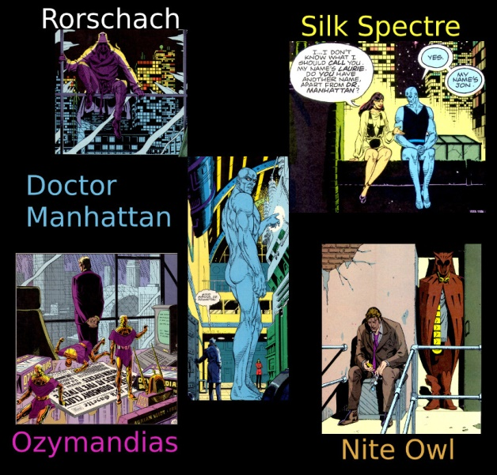

Written predominantly as a psychological exploration, the action in *Watchmen* is fairly limited but the moral and existential horrors drip from every page. Part social commentary, part critique of comics, part moral play, the 12-issue series was different from much (but not all as many critics believe) that was on the market at the time (the *Squadron Supreme* 12-issue series from 1985 has nearly identical themes – albeit dealt with differently – and premiered about a year and a half earlier, but that is a post for another day).

To emphasize that the *Watchmen* was something other than the run-of-the-mill comic, writer Alan Moore and artist Dave Gibbons, tried to design a look-and-feel quite different from anything that was currently in vogue. They did this in a number of interesting and successful ways:

* Page layout
* Panel detail
* Background material
* Repeated visual elements
* Repeated narrative elements

## Page Layout

Throughout almost every page of the visual material, Dave Gibbons uses a 3x3 grid with the smallest panels measuring about 2 inches wide by about 3 inches high. The main variation in this layout is to combine these atomic panels into composites that span more than one column and/or row. Despite Moore’s protests to the contrary, this gives the entire series a movie storyboard feel, as seen in this ‘silent sequence’ showing how Rorschach gets into the Comedians apartment at the start of his investigation

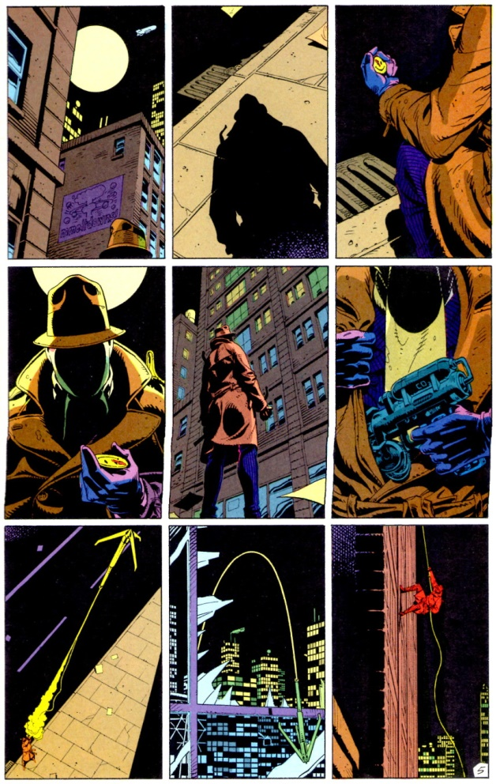

This is why so little of the core plot needed to be cut from the successful adaptation of the *Watchmen* movie (and in fact some new material was added). Gibbons does depart from the strict 3x3 grid in a few places (page 6, 12, 16-7 & 27, and 28 of issues #1, #2, #7, and #11, respectively) but these are places where time is meant to move more slowly than in the normal pacing of the book.

Perhaps the most interesting experiment and one that I missed until it was pointed out to me, is that issue #5, entitled *Fearful Symmetry*, is completely symmetric front to back (a comic book palindrome). For example, the first three pages are in a 3x3 grid with Rorschach at the apartment of an old supervillain named Moloch. Likewise, the last 3 pages (26-28) are a 3x3 grid showing Rorschach at Moloch’s apartment. Page 9 is a mirror image of page 20, both having a 3 panels per row (one spanning two columns in each) and both dealing with the comic-within-a-comic story about the *Black Freighter*. The central opposing pages (14 and 15) have one continuous fight sequence rendered in ‘fearful symmetry’.

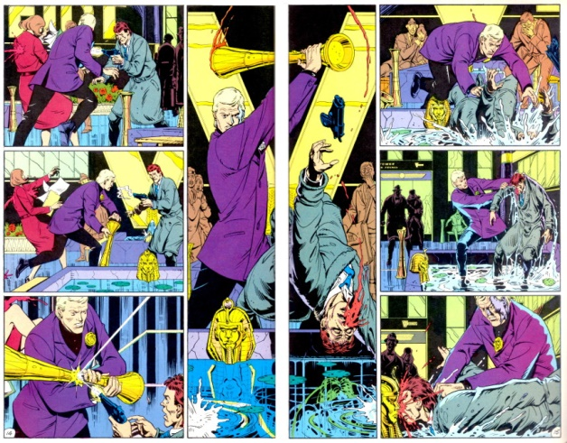

## Panel Detail

Besides the overall panel placement within the page, Dave Gibbons put a great deal of effort into the contents of each panel as well. As can be seen at a glance, the detail in each panel is top notch, but attention to detail for art’s sake alone is not nearly as impactful as is detail that advances the story for the careful reader.

Below is a panel from one of the many street scenes in New York. The first things that grab ones attention in the background are the advertisements for the ’86 Buicks and the Nostalgia perfume – both serve a purpose. While the Buick ad helps to remind the reader (especially the new ones) when this piece is set, it is the Nostalgia ad that actually provides important clues linking Veidt with the plot to hoax the world. The newspaper in the foreground gives the reason for Veidt’s intervention – the nuclear war that is about to break out between the USA and the USSR.

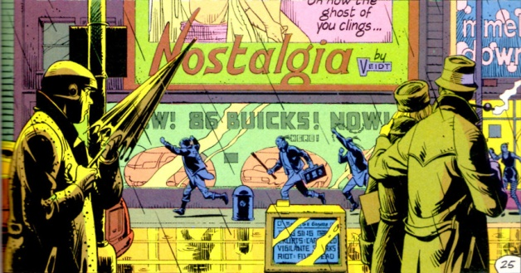

Scores of panels all throughout the series provide similar clues linking the World War III events with Veidt’s scheme to bring the world kicking and screaming back from the brink.

## Background material

Since psychology plays a crucial part in the *Watchmen* storyline, Moore provides extra, non-comic material, usually spanning the last 4 pages. These materials include: excerpts from books and articles written by the main characters, which enable us to get inside their heads; dossiers and internal memos from the various institutions associated with other main characters; and news and magazine articles that reveal the public mood and discourse to the reader. One cannot fully appreciate what is happening in the gutters and why it is happening without taking the effort to ‘research’ the *Watchmen* world.

## Repeated visual elements

Similar to the panel detail discussed above, Moore and Gibbons link various events together with repeated visual elements. The most well-known one is the smiley face motif that links the Comedian with cataclysmic events that started the whole chain of events that ends with a

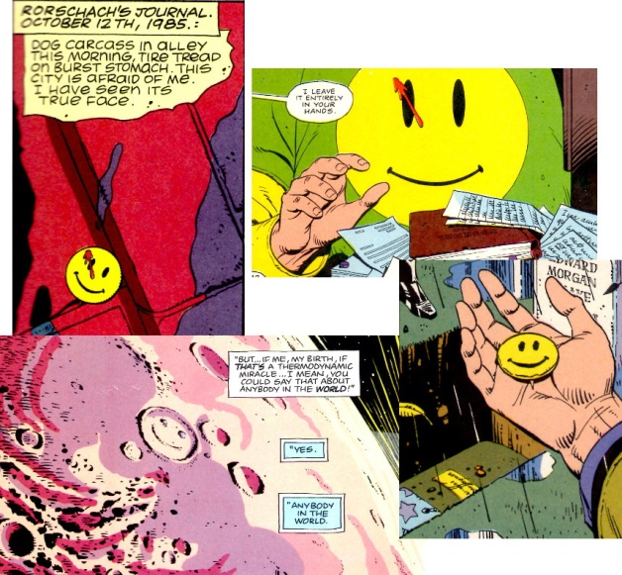

A less obvious visual motif is the reoccurring imagery of the Nostalgia perfume. Not only does it link Veidt to the desire to change, it provides a vital link to Ozymandias in that the perfume bottle, when turned on its side, looks like a letter Z contained within the letter O. This visual linkage appears at least 7 times in issue #9 when Laurie (Silk Spectre) and Jon (Doctor Manhattan) debate whether life has any meaning while they travel across the face of Mars.

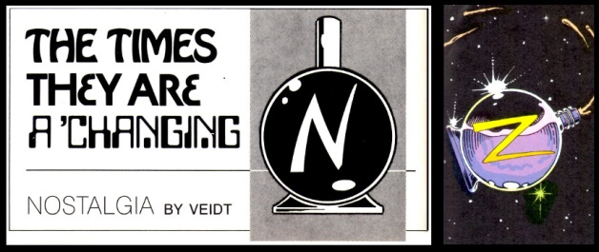

The most disturbing repeated element concerns the behavior of the Comedian, aka Eddie Blake, around women. It seems that Blake believes that women are there for his gratification and he easily brutalizes them when they don’t behave. It is interesting to note that in the two cases shown in the book, when Blake begins to ill-use a woman, her response is to attack by scratching/slicing the right side of his face.

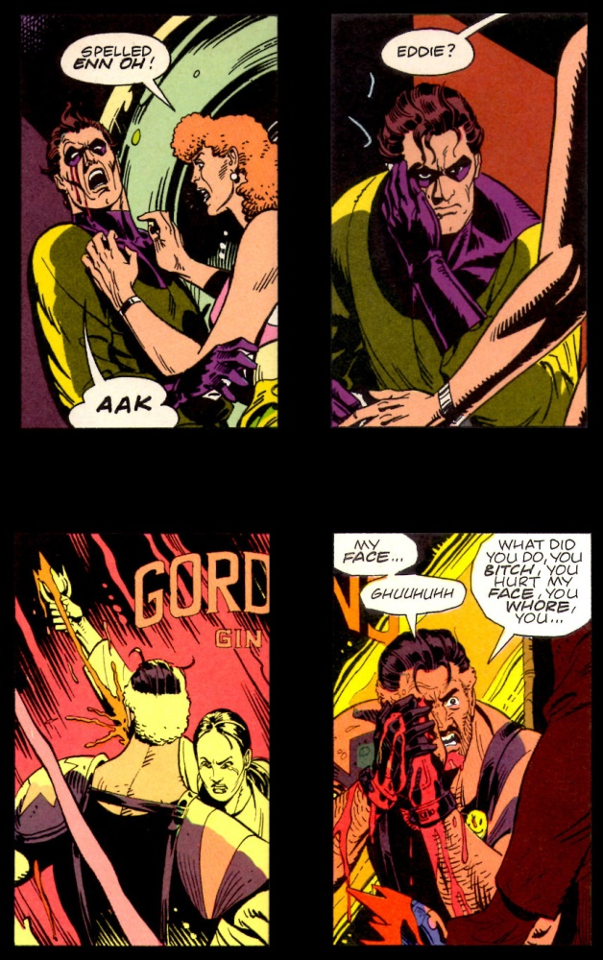

These scars remain with him until he dies – an outward symbol of his inward sins perhaps.

## Repeated narrative elements

The final method used by Moore and Gibbons is the linkage between disparate sub-storylines by using the kind of transitions that Moore discusses in his book on writing comics (see [*Story Construction – Part 7: Just One Bit Moore*](http://aboutcomics.blogwyrm.com/?p=443)).

The first panel below shows how, with some dark humor, Moore is able to transition from Rorschach’s monolog that begins issue #1 to the detectives investigating the death of the Comedian.

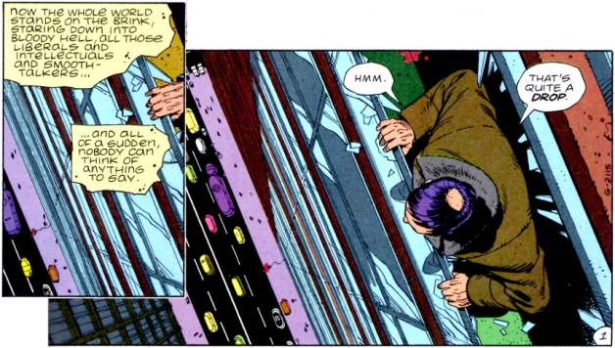

This next example is a classic movie transition that signals a flashback to earlier times and happier events (ah Nostalgia).

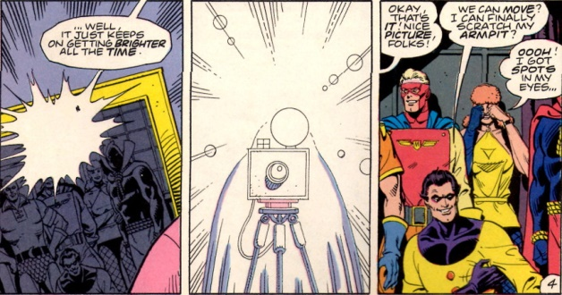

All told, these five elements make the form of the *Watchmen* a pleasure to see, to read, and to ponder. They go a long way in explaining the enduring success of the series and they certainly are the best part.

Next month, I’ll analyze the content of the *Watchmen* messages and not just the beautiful package in which they are wrapped.

Last month I reviewed the compositional elements of *Watchmen* that made the book a genuine work of comic book art. Moore and Gibbons primarily used 5 different and complementary compositional elements (page layout, panel detail, background material, repeated visual elements, and repeated narrative elements) in a consistent but unobtrusive way during the 12-issue run and, in doing so, created a critical and commercial success.

This month I want to examine the underlying philosophical themes and messages that the story conveys. The central point with which *Watchmen* wrestles is one of existential nihilism; the notion that human life is meaningless, banal, without purpose and that morality, as a result, is a convention or societal trapping at best.

While Gibbons claims that *Watchmen* ultimately celebrates the superhero genre and, therefore, rejects existential nihilism, there is little in their work that actually supports this assertion. It is true that at ‘the end’ of the series, a sort of equilibrium is achieved wherein the surviving main characters have found that the human race has value (no individual member per se; simply the race as a whole), but the justifications rest on weak first principles about the nature of man. Throughout the series, it is easy to find Thomas Hobbes’s famous characterization of human life as being ‘solitary, poor, nasty, brutish, and short’ being expressed by almost every character, large or small, each in his own distinct way.

The Comedian (aka Edward Blake) is by far *Watchmen*’s poster boy of existential nihilism. His code name derives from the cynicism he has about the value of human existence and the fact that he sees into ‘the joke.’ As a result, he doesn’t put a lot of stock in humans or their institutions and Moore and Gibbons afford us many opportunities to see inside of his philosophy. The most telling are his interactions with Doctor Manhattan (aka Jon Osterman) in the Viet Nam war. At Blake’s funeral, Manhattan reminisces about their time in Viet Nam.

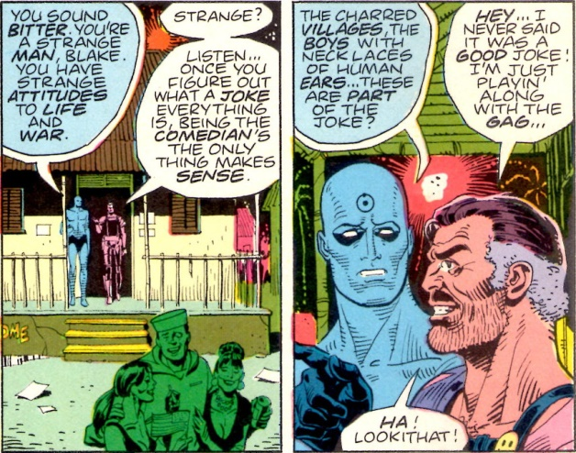

The time they spend together seems to have a profound effect on Doctor Manhattan, driving his already detached attitude even further away from compassionate sensibilities and into cynicism of his own.

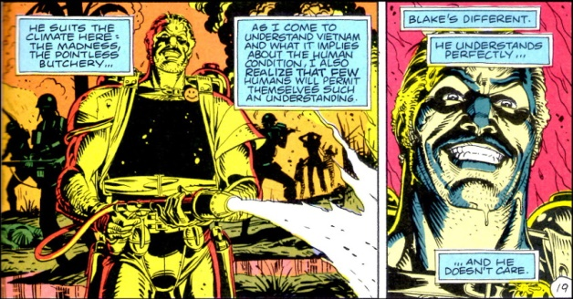

The Comedian’s own attitude seems to shift as he gets older and his cynicism, it seems, has limits. Moloch, once one of the most feared crime lords in the *Watchmen* universe, becomes an unexpected confidant of the Comedian’s. Blake breaks into his apartment for a little heart-to-heart. Having discovered Ozymandias’s (aka Adrian Veidt’s) plot to sacrifice millions to save billions, Blake is on the verge of a nervous breakdown and openly weeps in front of Moloch as he opens his soul about his past sins and how disturbed he is over Ozymandias’s plan.

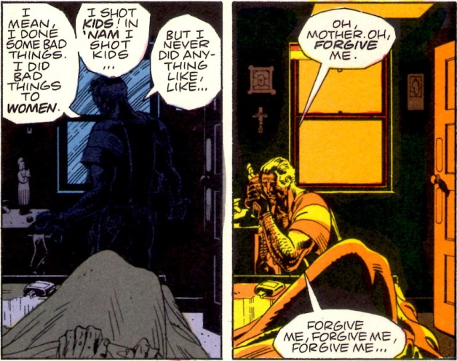

It isn’t explicitly stated but I am left with the impression that this change in Blake’s attitude is the result of his realization that his own daughter could be one of the victims of Veidt’s plan. In other words, that Blake finds some limit to his nihilism seems to result from the biological fact that he has a child.

By the start of Watchmen, it is uncertain how much of Doctor Manhattan’s attitude is shaped by his interactions with the Comedian and how much is the result of his ‘other-worldliness’. What is certain is that he claims to no longer find value in human life,

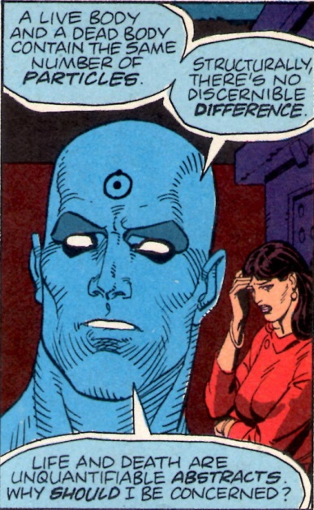

despite the fact that he has a human lover in the form of Laurie Juspeczyk (Silk Spectre II). Regardless of what he says, Jon still possesses enough human emotion to be easily manipulated into leaving the Earth for Mars. His absence is engineered by Veidt/Ozymandias precisely so that the latter will have no impediments for his great plan of salvation (essentially the same reason that Veidt kills the Comedian). However, Jon’s emotional attachment to Laurie Juspeczyk leads him to bring her to Mars, where she tries to convince him that human life has meaning.

Each of her arguments fails utterly and it looks like there is no possible way for her to convince Jon to return to save the world. It is only in the last minutes of their dialog that the situation changes. Jon unwittingly enables her to correlate all her memories and to realize that Edward Blake – the man who once tried to rape her mother – is her father. This sudden realization changes Jon’s perspective on the human race and allows him to see people as a thermodynamic miracle.

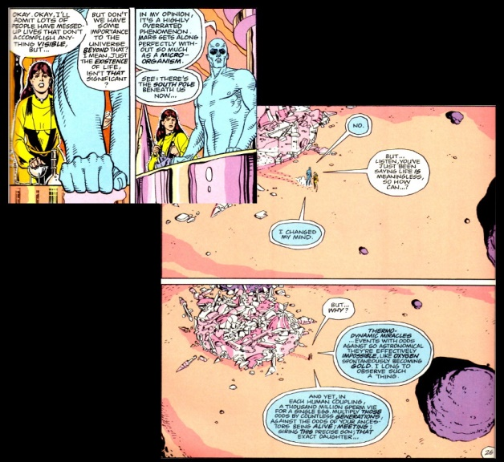

The most curious attitudes about the human race come from Walter Kovacs (a.k.a. Rorschach). Outwitted and framed by Veidt for Moloch’s murder, Kovacs is captured by the police, held at Sing Sing penitentiary, and forced to undergo mandatory psychological counselling by Malcom Long.

After days of evasion, Kovacs explains to Long how he got his unique ‘face’

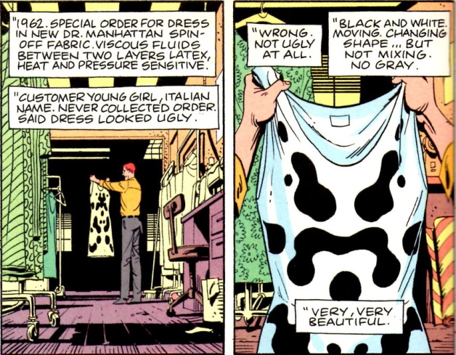

and the connection between this ever shifting viewpoint on black and white and how he decided to adopt Rorshach as his superhero persona.

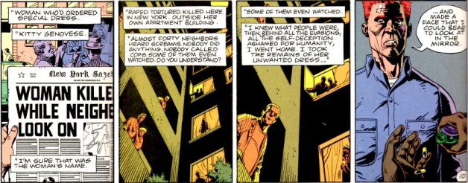

It should be noted that the modern viewpoint of the [Kitty Genovese story](https://en.wikipedia.org/wiki/Murder_of_Kitty_Genovese) is that the *New York Times* exaggerated the indifference of the neighbors, neglected to mention that the cops were called twice, and failed to state that no one could clearly see or hear what was happening in that alleyway. Nonetheless, Moore makes a lot out of this story and how it influences Kovacs into becoming Rorshach.

The last evolution for Kovacs occurs when he takes on the case of the kidnapping and butchering of a little girl. The particular brutality of the monsters who killed this little girl when they realized that she wasn’t the daughter of a rich man but simply shared the name drive Rorschach into becoming a monster himself. After that pivotal event, Rorschach is the prime personality and Kovacs is the mask.

The title of issue #6, in which Long discovers the truth, is *The Abyss Gazes Also*, a clear reference to the famous quote

<Battle not with monsters, lest ye become a monster, and if you gaze into the abyss, the abyss gazes also into you. = Friedrich Nietzsche>

And true to this sentiment, by the end of the session where Malcom Long discovers the truth behind Rorschach, he too is embracing nihilism.

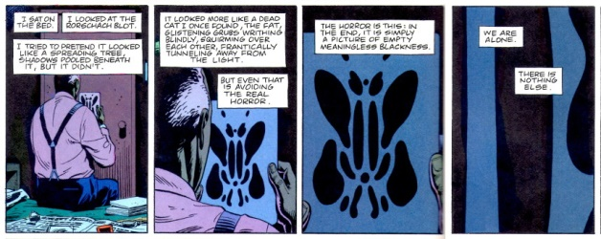

Perhaps the most interesting of all the *Watchmen* characters is the one who, through the bulk of the series, gets the least attention – Adrian Veidt, aka Ozymandias. Dubbed the most intelligent man on the Earth, Veidt is fascinated with the ancients and their approach to life. In particular, he admires the campaign and conquering of Alexander the Great, even though he has taken as his superhero name the Greek name of the great Pharaoh Ramses II.

Originally planning to make a difference as a costumed adventurer, Veidt’s perspective changes abruptly under the influence of the Comedian, who argues that no amount of small scale crime fighting will change the basic equation of the Cold War.

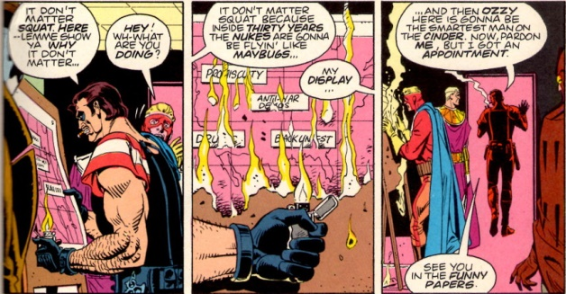

Soon after, Veidt gives up his masked persona and seemingly retires to become a highly successful captain of industry 2 years before the government eventually declares all masked adventurers outlaws. In actuality, Veidt is merely the mask that Ozymandias wears as he engineers his world-saving solution. As he explains to Rorschach and Nite Owl, the Cold War was a modern Gordian Knot; something that needed to be solved by out-of-the-box thinking.

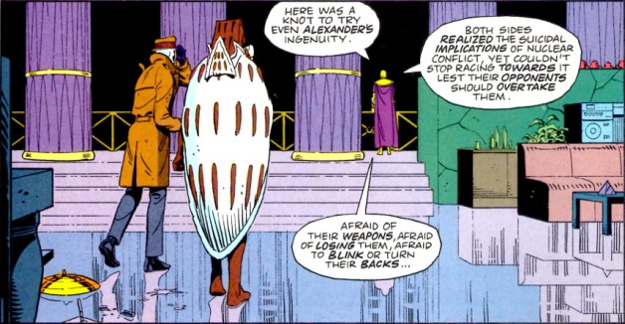

Thus Ozymandias engineers the plan for a mock alien invasion that will unite, at least briefly, the entire Earth as one brotherhood.

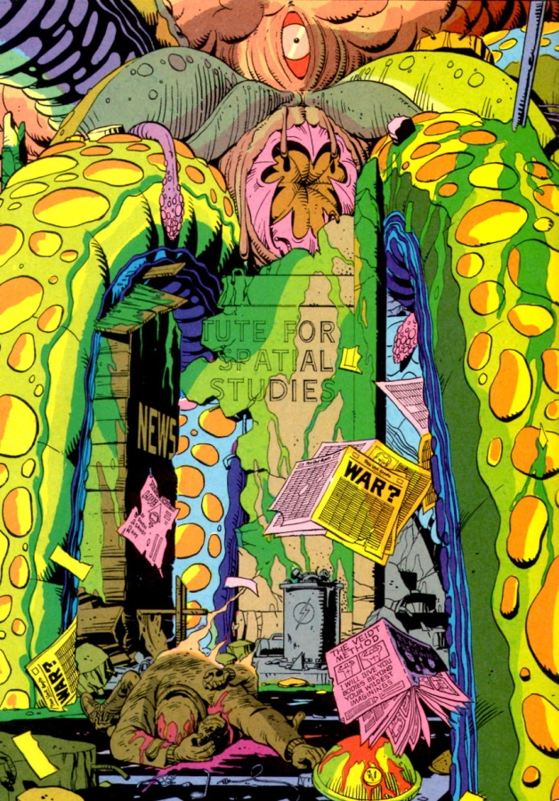

The fact that millions die so that billions live is something that Ozymandias seems to be able to live with and justify. Nonetheless, Moore and Gibbons suggest, though their *Tales of the Black Freighter* comic-within-a-comic, that Ozymandias through his struggle to stop the monsters of the human condition has become one himself.

The *Tales of the Black Freighter* is introduced and presented to the reader through a young boy who hangs around a newsstand to read the reprinted editions of this classic horror comic written years before. This comic-within-a-comic is visually distinct from everything else in the Watchmen and is given out in installments. As a compositional element, it is interesting in that it serves at least three distinct functions: it gives homage to the old EC comics of the 1950s; it represents one of the few attempts at a frame tale in comics; and it serves as a vital element to explain Ozymandias’s psychology.

The two-part story focuses on an unnamed man who is marooned on an island after his ship has been attacked by the ship from hell called the Black Freighter. Initially dismayed by the threat the damned pirate ship represents to his home town, the man fashions a raft from the dead bodies of his compatriots. The horrors he endures and embraces eventually take him from genuine concern for this family, through the hunger for vengeance, and finally to a willingness to sacrifice innocent lives to see his loved ones protected. This final action results in his ultimate damnation aboard the very ship he loathes.

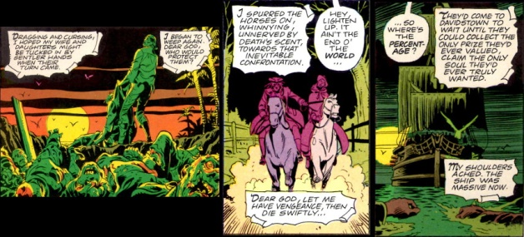

This narrative metaphor is meant to emphasize the sentiment of Nietzsche who warns of the cost when battling monsters – a theme that Moore attaches to the actions of the superheroes of the *Watchmen*.

Of course, not all characters embrace nihilism. There seem to be three or four genuinely ‘nice’ characters: Nite Owl I (Hollis Mason) and II (Dan Dreiberg), and Silk Spectre I (Sally Jupiter) and II (her daughter Laurie Juspeczyk). The positions and arguments against existential nihilism from these characters are not mounted in any serious way. Both Mason and Dreiberg are portrayed as powerless characters. Mason dies at the hands of a gang of hoodlums, and Dreiberg (who is the ‘knight’ of the story – see the additional material at the end of issue #7) is shown to be both sexually and strategically impotent. Sally Jupiter is shown to be in it for the money and to be materialistic and shallow. Laurie is first introduced as the sex kitten used to keep Doctor Manhattan happy and, when introduced later as a costumed adventurer, she, of all the main characters, is not provided a dramatic pose that features her alone (see the team image from last month’s post).

So, what to make of existential nihilism in Moore’s story? Well, it seems that Moore pulls from Nietzsche here as well, when the latter states “If we affirm one single moment, we thus affirm not only ourselves but all existence.” But the affirmations provided in *Watchmen* are weakly supported and full of strong metaphysical contradictions. For example, the Comedian’s point about seeing the joke implies the existence of a jokester to tell it, in turn implying purpose to human life; a point further emphasized by Blake’s ‘biological repentance’ once he knows he is a father. Doctor Manhattan’s grasp of thermodynamics, statistical mechanics, the structure of spacetime, and quantum mechanics should afford him a better grasp on metaphysics so that the human mating revelation he has on Mars should have never needed to be. This is especially troubling given the notion of predetermination that comes from Doctor Manhattan’s ability to see past, present, and future simultaneously.

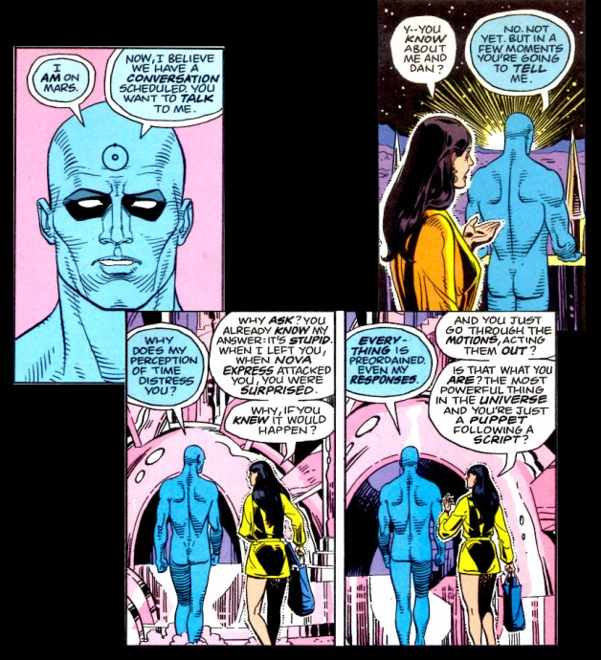

Rorschach finds only value in abstract things like Justice and Truth but finds no motivation in Love or Beauty, so how does he truly know Justice? So he hates the human race, for whom he fights, but continues on fighting.

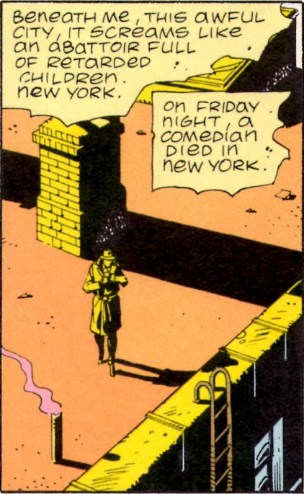

Ozymandias sees only value in control, so the thing that is worth controlling (here the human race in total) has value, but it isn’t clear why he values the race while valuing no single member within. In addition, the world’s smartest man, who is capable of engineering this alien invasion plan, is not smart enough to have standard password protection.

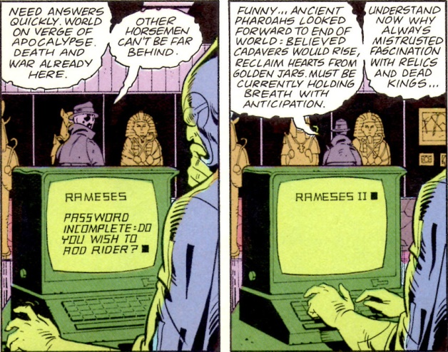

The superhero genre, like the classic epics and mythology on which it is built, always has nobility and baseness side-by-side. Characters of profound capabilities put their gifts to use, both good and bad, even if they themselves are not necessarily good or evil. The classic superhero story doesn’t deny the existence of horror or evil, but rather celebrates those individuals who can look into the abyss without becoming monsters. In the *Watchmen* one finds only the baseness, only the abyss, and only the monsters.

So if the compositional elements of *Watchmen* can be regarded as the wrapping paper on the outside of a gift box and the themes of existential nihilism can be regarded as the gift inside, then the Watchmen is one gift best admired for how it looks unopened.